Sports Leaders - Level 3 Qualification in Sports Leadership
What are the required skills and behaviours leaders may be required to use?
What makes a good ‘leader’, what makes a bad ‘leader’?
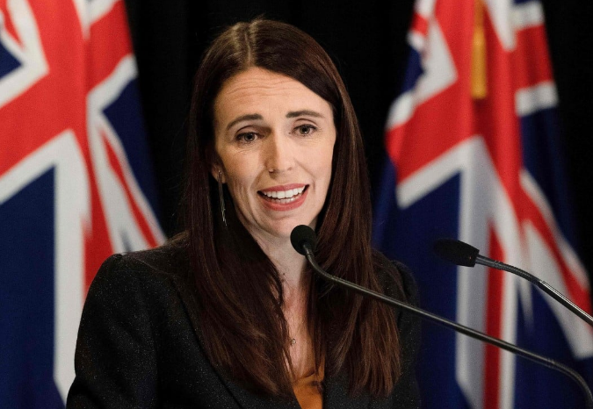
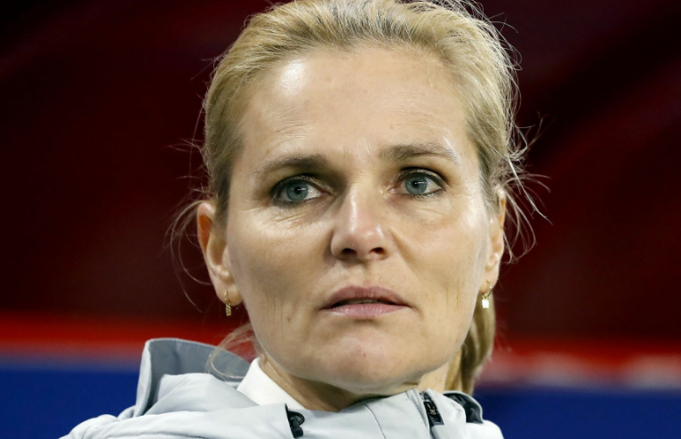
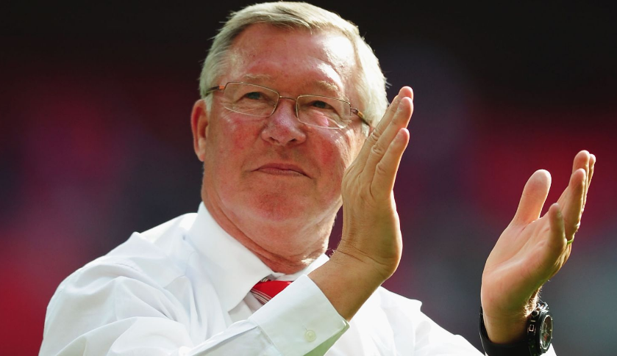
Relating leadership to sport, can you define what a good coach is, what key attributes should they have, can you name some and give reasons why?

