LIFE SKILLS
Preparing sixth formers for the challenges, opportunities and responsibilities of life.

Preparing sixth former’s for the challenges, opportunities and responsibilities of life

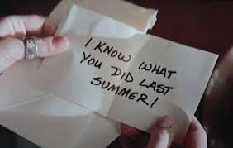

This Summer term and Summer holidays provides you with an ideal opportunity to develop your 'BRAND' - yourself and your skills.

Below are some challenges you could do and earn yourself points for the Life Skills program that you will do in the sixth-form at WGS. It will give you a head start to gaining your Gold Life Skills Certificate. If you chose not to return to WGS sixth-form then the challenges will give you the opportunity to develop your CV and give you very important life skills.
FIRST AID
https://www.protrainings.uk/courses/64-student-first-aidc

You need to proceed to check-out and see that the course if free. You have to enrol and then begin. Once you have completed the course you will be able to download your certificate.

British Sign Language

www.british-sign.co.uk

A fantastic opportunity to learn Sign Language for a minimal fee of £3 whilst in lock down. Click on the link above and follow the instructions to the link at the bottom of the page.
DAILY CHALLENGES
https://vimeo.com/user/19239204/folder/1604283
- Environment and Sustainability
- Homelessness
- Wellness and Wellbeing
- Food Poverty and Insecurity
- Equality and Discrimination
Please click on the link above to access 5 challenges on the topics listed
TED TALKS
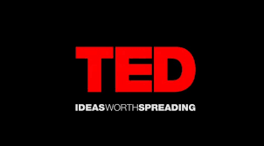
TED TALK
Choose a TED Talk from the many that can be found online and complete the following tasks:

  - Write a brief summary of what the talk is about.

  - Explain why you have chosen this particular talk.

  - Complete ALL the analysis statements:

- I noticed.....
- A question I have is.......
- I wonder why.......
- I began to think of.....
- It seems like.......
- I can’t really understand.....
- I’m not sure.....
- I know the feeling......
- I loved the way.....
- I realised.....
- I was surprised......
- If I were......
- I discovered........
IRONING
https://www.youtube.com/watch?v=yK6iQj-I_0w
Watch the above video and then Iron 5 shirts/blouses

CURRENT AFFAIRS CHALLENGE
CURRENT AFFAIRS
  - You need to choose ONE important event from the past Year. It cannot be a sporting event, entertainment or celebrity gossip.

  - Outline the event as if the person reading wasn't there or aware of it in around 50 words.

  - Analyse the event using the 5 W's. Write out the question and then answer it. Making sure that there is a line between each question. Remember that there can be more than one question for each W:
    - Who?
    - What?
    - Where?
    - When?
    - Why?

