AQA Economics - https://www.aqa.org.uk/subjects/economics/as-and-a-level/economics-7135-7136

A good economics student not only knows their theory, i.e., the content that is on the specification,
but also thinks like an economist. Economics is a subject that surrounds us all day, every day. It is a
real-life subject that appears on the news and online. Variables change constantly, as do peoples
behaviours and attitudes. A good economist is inquisitive, well-read, curious and diligent.

Doing some preparation prior to starting the course will be very useful for you; we suggest that you do a range of things:

- Keep up to date with the news relating to national and global events. This will start to give you a good understanding of the terminology we use in the subject and how different economic variables are interdependent - interlinked and impact on each other.

Recommended websites / follow on Twitter / Apps on your mobile

  www.tutor2u.net  Excellent website with everything you need to learn for Economics A Level, presentations, videos, revision quizzes. You can sign-up for daily blogs – follow the link below: https://cm.tutor2u.net/h/j/BF69E62691E77D33 | 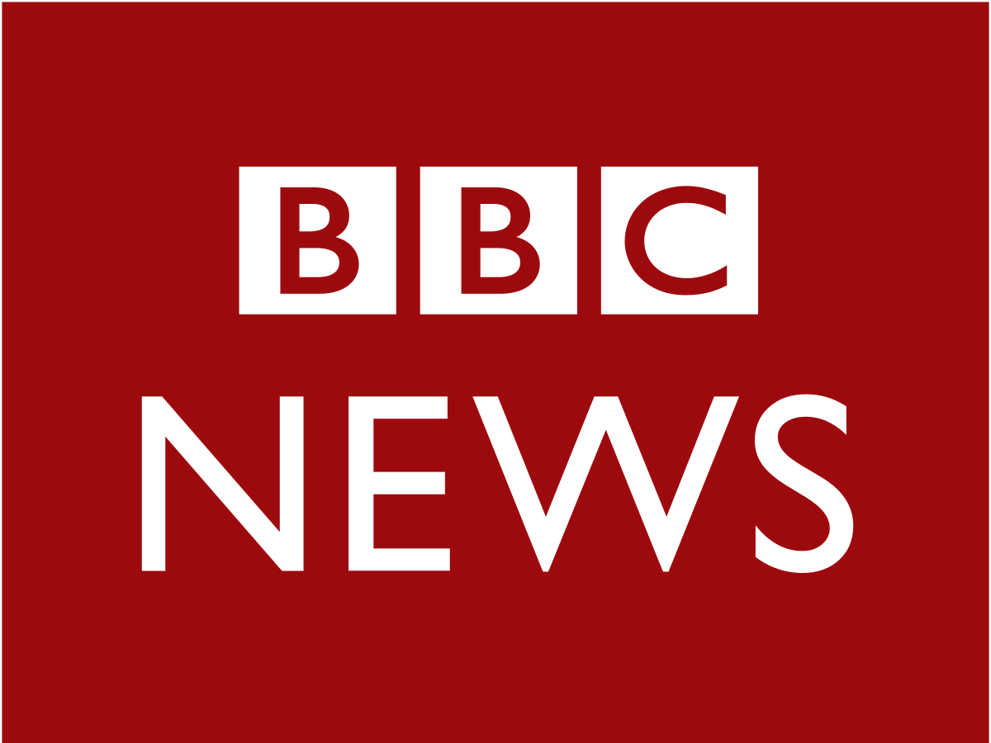  www.bbc.co.uk  Excellent news website with everything you need to learn about what is going on in the world today. You can sign up for daily emails. Follow the link below:  https://www.bbc.co.uk/newsletters/bbcnewsemails/ | A-Level Economics Resources Overview: Resources and Articles  Superb notes from Tom Furber (above) and below a link to resources from Tooting Tutors  A-Level Economics
  https://www.economicshelp.org/  Excellent website with resources such as essays,  e-books, blog posts and the latest developments on the UK and global economy.  It also has a good set of revision notes.  Please see the link to Physics Maths Tutor Resources https://www.physicsandmathstutor.com/economics-revision/a-level-aqa/ |   https://ig.ft.com/sites/numbers/economies/uk/  Excellent website for researching the UK economy at a glance. The FT’s one-stop overview of key economic data, including GDP, inflation, unemployment, the major business surveys, the public finances and house prices.  You have access to free resources – follow the link below: https://professional.ft.com/en-gb/services/professional-subscriptions/secondary-education/ |   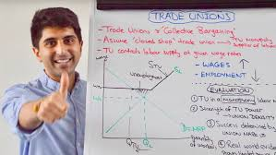  ECONPLUSDAL  Brilliant l YouTube channel with a wide range of revision videos on all economics A level topics. Dal is the King! Loved by all the students

- Undertake some wider reading – see the list at the bottom of the page.
- Watch television programmes such as BBC News at 6 or 10, Panorama, Dispatches, News Night, Question Time, Channel Four News at 7 - These will often discuss economic issues.

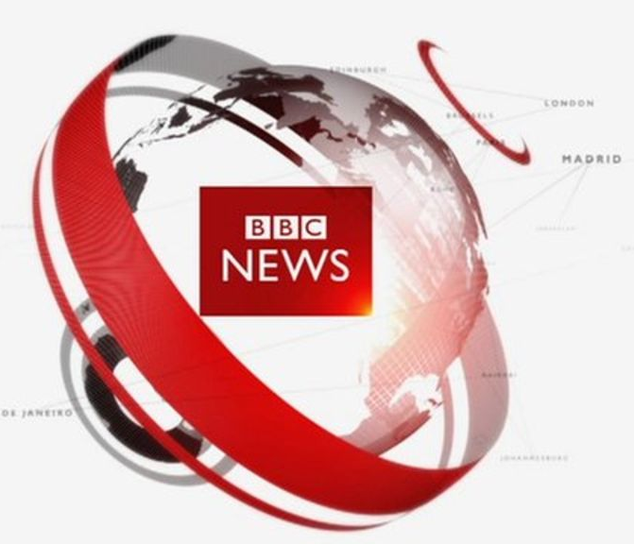  BBC News  Last news from around the world. |   BBC Panorama  British current affairs documentary programme |   BBC newnight  Key national and international news stories

The course is split into two sections; Individuals, Firms, Markets and Market Failure is primarily microeconomics, and the National and International Economy is primarily macroeconomics.

At the end of year 2 you will complete three exam papers (each is 2 hours in length) as follows:
- Paper 1: Market and Market Failure
- Paper 2: National and the International Economy
- Paper 3: Economic Principles and Issues

Each paper is worth 33.3% of the A-level qualification

Preparation

To start with, try to think about what you think is involved in studying economics:

- In less than 15 words sum up what you think economics is about.

- Write down 5 things you know about the economy or the study of economics.

- What do you think about TWO current economic issues? E.g., Globalisation? Inequality? Climate change? The cost-of-living crisis? The impact of Brexit and the pandemic on the UK? The impact of the Russian/Ukraine conflict and conflicts in the Middle-East?

- Are you aware of any famous economists? Do you share the same views as anyone in particular? If not, think about researching some different approaches. You may want to look at Monetarism – Milton Friedman and Keynesianism – John Maynard Keynes or the father of economics – Adam Smith.

- What are your main economic beliefs or ideals? Are they like your political or social leanings?

Introduction

Watch the You Tube clip – Introduction to economics

https://www.youtube.com/watch?v=sPnQiIZzZtw&feature=youtu.be

Create and complete the table below to show what you have learnt about the study of economics.

Economics

Microeconomics | Macroeconomics

Check your understanding of the terms microeconomics and macroeconomics.

Task 1 – Price Determination

This is a topic that you will study in microeconomics.

In May 2026 the BBC reported that it would cost around £80 to fill an average family car with petrol and the RAC reported that unleaded petrol was 157.7p per litre. A key topic in economics is price determination.

- Do you think this is a micro or macro topic? Justify your answer.

- Create a mind-map showing the factors that you think affect the price of petrol.

Good economics students keep up to date with national and global events and can apply the theories that they learn to current news stories and events in their essays. With this in mind read the following BBC story:

Fuel prices: Why is petrol so expensive in the UK?

What is happening to UK fuel and petrol prices? - BBC News

- Read the introduction and section on “How do wholesale oil prices affect the cost of petrol and diesel at the pump”
- With a different coloured pen are there any other factors that you would like to add to your spider diagram?

- Did demand increase or decrease?

- Was this because of a change in price or other factors?

- Now consider all the factors that contributed to the increase in the price of petrol. Put your list in a table, in order, with the most significant factor at the top. Justify your rankings:

Factor | Justification of ranking

One factor affecting prices is the degree of competition in the market. If there is a lot of competition, then power sways towards the consumer as they have a greater choice. If there is little competition, then the power sways towards the supplier.

- With this in mind, and considering the BBC article, explain how the degree of competition in a market can affect prices.

Task 2 – Rising Cost of Living

The term “cost of living” refers to a period of time during which the cost of everyday essentials like food and bills increases more quickly than average household income. The UK has been experiencing a cost-of-living crisis since late 2021.
Although the cost-of-living crisis affects us all, those of us on lower or fixed incomes are disproportionately impacted. Why do you think this is?
Read the research briefing from the House of Commons Library by following the link below. It contains some important background information about why the price of everyday essentials has been going up.
High cost of living: Impact on households - House of Commons Library

Using the article and your own wider research, answer the following questions:

- Define inflation.

- What is the name of the inflation measurement used in the report?

- What caused the high inflation?

- How has the Bank of England (BofE) responded to high inflation?

- Stretch question- Why do you think the BofE has responded in this way?

- What has been the impact of high inflation on households?

- Stretch question– Why are people in low-income households affected the most?

- What has happened to inflation and interest rates since this report was published?

Whilst the information from the House of Commons dates back to 2024, the cost of living is still a problem that households are facing today. Look at the articles below to understand what the current issues are.

Rising costs forcing 3m UK households to skip meals, Which? report finds | UK cost of living crisis | The Guardian

Food price inflation still rising, as lower income households feel the squeeze, study says | UK News | Sky News

Your summer reading and viewing list

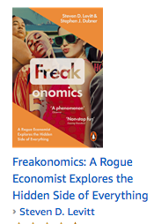

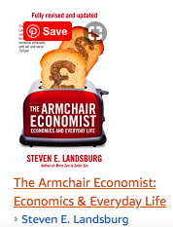

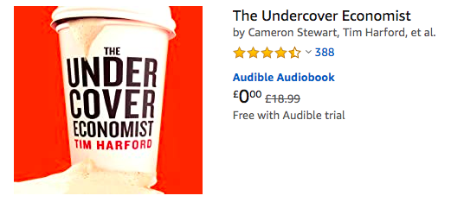

And any of the subsequent books
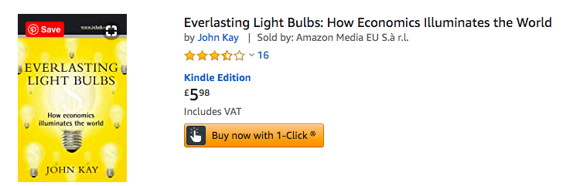

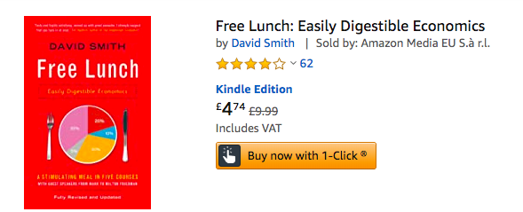

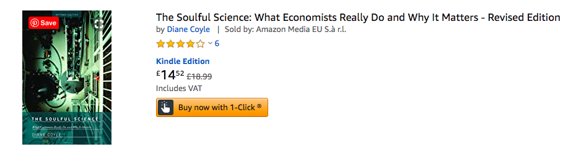

You will also be given the opportunity to subscribe to The Economist in September at a very reduced rate – usually 30p per copy instead of £5.00!

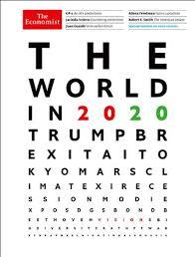

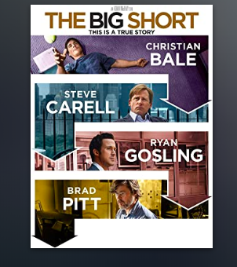

Can be found on Netflix. Based on the true story of four outsiders who saw what the big banks, media and government refused to: the global collapse of the economy.
Useful introduction to Financial Markets – Trading Places – Xmas feel-good film about traders.
https://tv.apple.com/gb/movie/trading-places/umc.cmc.298m4977kall3tddgiukhy2xm

