Items needed for lessons:
- Basic stationary
- Protractor
- Scientific calculator
We recommend they also bring the following to help with organisation:
- Lever arch folder
- Folder dividers

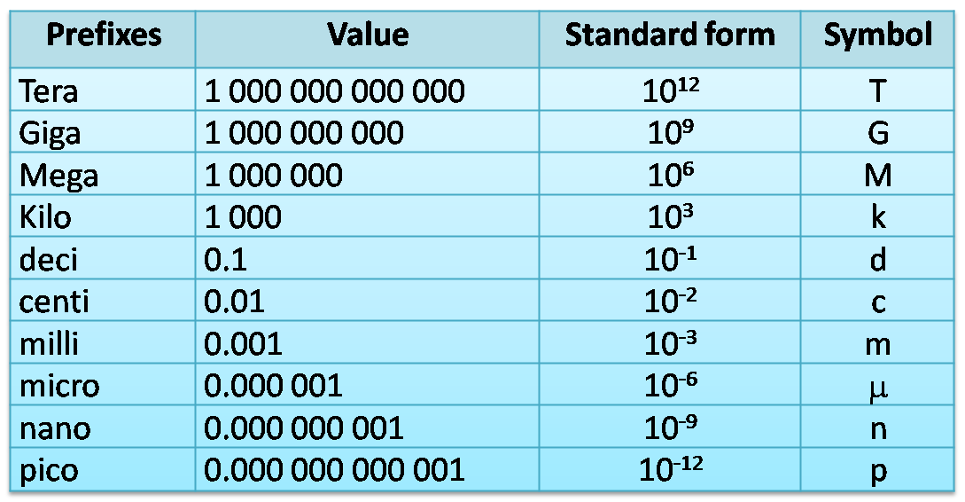
Suggested reading:
- ‘A Short History of Nearly Everything’ by Bill Bryson
- ‘Big Bang: The Most Important Scientific Discovery of All Time and Why You Need to Know About It’ by Simon Singh
- ‘A Brief History of Time’ by Stephen Hawking
- ‘The Making of the Atomic Bomb’ by Richard Rhodes
- ‘13 Things That Don’t Make Sense: The Most Intriguing Scientific Mysteries of Our Time’ by Michael Brooks
- ‘Surely you’re joking Mr Feynman’ by Richard P Feynman and Ralph Leighton.
- ‘Six Easy Pieces: Fundamentals of Physics Explained’ by Richard P Feynman (or any other book by the same author)
- ‘50 Physics Ideas You Really Need to Know’ by Joanne Baker

Suggested videos:
Videos:
• “Schools Lecture series” are videos made by the Institute of Physics. They are useful videos pitch at a level that is accessible by students, and they topics covered will really help you understand some of the details of the A-level course. The link is: http://www.iop.org/resources/videos/education/schools-and-colleges-lecture/page_50044.html
• minutephysics has a wealth of one-minute videos on a vast range of relevant topics. Subscribe and watch them. http://www.youtube.com/user/minutephysics
• Richard Feynman’s “Messenger Lectures” on physics, archived with transcripts on Microsoft’s Project Tuva website. http://research.microsoft.com/apps/tools/tuva/

Need help?
The sooner you learn to seek help from your teachers the higher the chance of success
CGP book “Headstart to A-level Physics” ISBN 9781782942818 - recaps all the crucial topics students will need to remember from GCSE, with study notes and examples, plus practice questions to test their understanding.
The questions that follow below are intended to identify areas you will need to master before you begin the course (we will help you if you do struggle a little). Please attempt these and bring them to your first lesson.

- Complete the following unit conversions;
a. 7.5g cm⁻¹ to kg m⁻¹? (2)
b. 12s mm⁻¹ to ms m⁻¹? (2)

- For the following equation, $$v = u +at$$ sketch a straight line graph so that V is the dependent variable and t is the independent variable; state what both the y-intercept and gradient are equal to. (4)

- Convert the following to standard form and 3 S.F.
a. 0.0009255 (2)
b. 89589 (2)

- Explain the difference using words and a sketch graph between elastic limit and the limit of proportionality on a force/extension graph for a spring. (4)

- Explain the difference between a vector and a scalar quantity. (2)

- A super-tanker has a mass of 500Mkg. Its engine can produce a thrust of 5MN. What is its maximum acceleration? How long will it take to reach a velocity of 1ms⁻¹? (6)

- What are the unit symbols for the following quantities?
a. Current b. Resistance. c. Velocity.
d. Acceleration. e. GPE. (5)
- Explain the concept of terminal velocity when applied to a parachutist. Ensure that you build into your answer how any laws of Physics are applied and what forces are involved. (6)

- What is the combined resistance of a 2 Ohm, 5 Ohm and a 10 Ohm resistor when used in parallel? (4)

- What p.d. would voltmeters 1 and 2 display? (2)
- As the temperature increases what would happen to the voltmeter reading? Explain your answer (3)
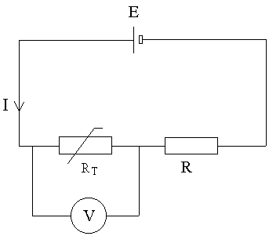
- What are the following conversions (give your answer in standard form):
- 560mm to km (1)
- 0.5mm to nm (1)
- 36MW to TW (1)

