STAFF ON DUTY |  | DATE | ACTIVITIES
Miller | Brodwell
Miss Winks  Mrs Crawford | Mr King  Mr Dobson | 13th and 14th January | Free Weekend
Mrs Bradburne  Miss Slater  Ms Evers | Mr Hicks  Mr Tennant | 20th and 21st January | 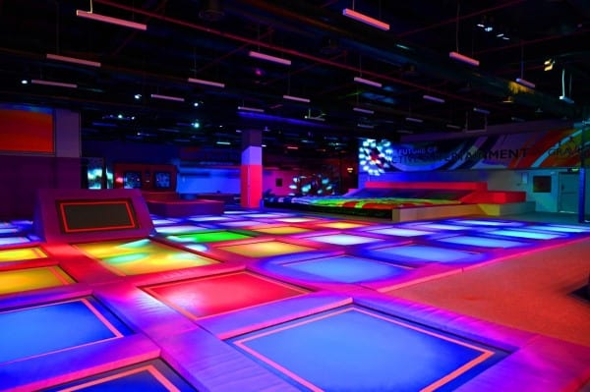  Trampoline
Miss Winks  Mrs Crawford | Mr Walker  Mr Jackson | 27th and 28th January | Mini Golf  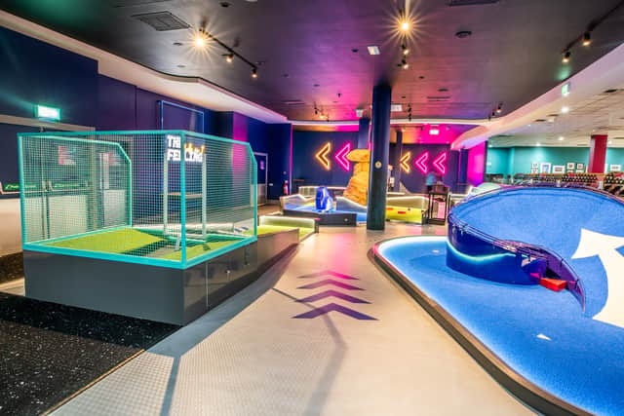
Mrs Bradburne  Miss Myers | Rev Drost  Mr Dobson | 3rd and 4th February | Go Karting  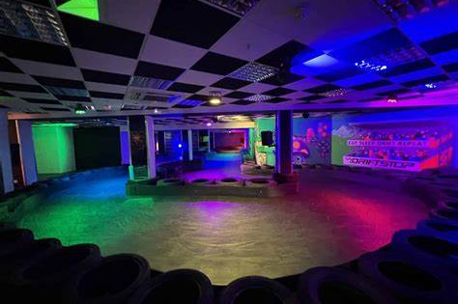
HALF TERM
Miss Winks  Mrs Crawford | Mr King  Mr Dobson | 24th and 25th February | Free Weekend
Mrs Bradburne  Miss Slater  Ms Evers | Mr Hicks  Mr Tennant | 2nd and 3rd March | Bowling
Miss Winks  Mrs Crawford | Mr Walker  Mr Jackson | 9th and 10th March | Cinema
Mrs Bradburne  Miss Myers | Rev Drost  Mr Dobson | 16th and 17th March | Free Weekend
Miss Winks  Mrs Crawford | Mr King  Mr Dobson | 23rd and 24th March | London  